ORRIS INFRASTRUCTURE PRIVATE LIMITED

Application Form
WOODVIEW RESIDENCIES
RERA Registration No.:
RC/REP/HARERA/GGM/418/150/2020/34
Dated 06.10.2020

Checklist of Documents to be submitted along with the Application Form
Mandatory to affix passport size photograph in designated areas in the Application Form towards all mentioned below categories:
Resident of India
Copy of PAN Card and Aadhar Card
Photograph(s) of Applicant(s)
Any other document/ certificate as may be required by the Company Residence Proof
Partnership Firm
Copy of PAN Card of the Partnership Firm
Photograph(s) of Applicant(s)
Copy of Partnership Deed
Incase of one of the Partner signing the document on behalf of other Partners an authority letter from other Partner authorizing the said person to act on behalf of the Firm
Private/Public Limited Company
Copy of the PAN Card of the Company
Photograph(s) of Applicant(s)
Articles of Association (AOA) & Memorandum of Association (MOA) duly signed by the Company Secretary of the Company
Board resolution authorizing the signatory of the Application Form to buy property, on behalf of the Company

Hindu Undivided Family
Copy of PAN Card of HUF
Photograph(s) of Applicant(s) Residence Proof
NRI/ Foreign National of Indian Origin: Copy of the Individuals Passport
Photograph(s) of Applicant(s)
In case of Demand Draft (DD) the confirmation from the banker stating that the DD has been prepared from the proceeds of NRE/NRO account of the Applicant
In case of cheque, all payments should be received from the NRE/NRO/FCNR account of the customer only or foreign exchange remittance from abroad and not from the account of any third party Residence Proof
Customer’s Signature: ______________________

Receiving Officer:___________________________

APPLICATION FOR BOOKING OF PLOT IN WOODVIEW RESIDENCIES, AT SECTOR 89 & 90, VILLAGE HAYATPUR & BADHA, DISTRICT GURUGRAM, HARYANA
Registered under Real Estate (Regulation and Development) Act, 2016 and Haryana Real Estate (Regulation and Development) Rules, 2017 vide registration no. RC/REP/HARERA/GGM/418/150/2020/34 Dated 06.10.2020.
Date: ___________________
Existing Customer: Yes 🖵 No 🖵 | Customer ID (If Yes): __________________________

Orris Infrastructure Private Limited,
J-10/5, DLF, Phase-II,
M.G. Road,
Gurguram (Haryana) – 122 002
Subject: Application for booking of a residential plot in project “WOODVIEW RESIDENCIES” situated at Sector 89 & 90, Villages Hayatpur & Badha, District Gurugram, Haryana being developed by Orris Infrastructure Private Limited.
Dear Sir(s),
I/We, the Applicant(s), whose particulars are mentioned below in this Application, agree and understand the following:
- That Orris Infrastructure Private Limited (hereinafter referred to as “Promoter”) has conceived, planned and is in the process of developing, constructing and promoting a Residential Plotted Colony on a piece and parcel of land admeasuring 114.506 acres, situated at Sector 89 and 90, Villages Hayatpur and Badha, District Gurugram, Haryana (hereinafter referred to as the “Scheduled Land”) under the name and style of “WOODVIEW RESIDENCIES” in accordance with requisite approvals from the competent authorities, which inter-alia includes plots, villas, independent floors, commercial complex, open areas, landscaped gardens, etc. (hereinafter referred to as the “Residential Plotted Colony”).
- The Promoter has entered into collaboration agreements (hereinafter referred to as “Development Agreements”) with the land owners of the Scheduled Land for the development of the Scheduled Land and is hence competent to market and sell the plots in the Residential Plotted Colony.
- Pursuant to the said Development Agreements, between the Promoter and the land owners (being subsidiaries of the Promoter and also individuals), the Promoter was granted License nos. 59 of 2013 dated 16.07.2013 for 101.081 acres and License no.115 of 2019 dated 12.09.2019 for 13.425 acres by the Director, Town and Country Planning, Haryana for setting up a Residential Plotted Colony on the Scheduled Land.
- The Promoter is in the process of developing 576 nos. of residential Plots of different sizes, under the name of “WOODVIEW RESIDENCIES” (hereinafter referred to as the “Project”) and the Project is registered under the Real Estate Act vide Registration no. RC/REP/HARERA/GGM/418/150/2020/34 Dated 06.10.2020.
- The Promoter is presently inviting applications for the booking of the independent residential plots in the said Project of the Residential Plotted Colony. The Applicant(s) has been intimated that though the Project has various components including independent floors, villas and apartments, EWS, shopping malls, community facilities like schools, medical facilities, community centre / club etc. this Application shall be confined and limited in its scope to the Plot in the aforesaid Land. I/We, the Applicant(s) have been intimated that this Application shall be confined and limited in its scope to the plot in accordance with the terms and conditions of license(s) granted by the competent authority.
- I/we, the Applicant(s), after having read, understood and agreed with the terms and conditions (“Terms & Conditions”), annexed hereto and the terms and conditions contained in the buyer agreement/agreement for sale prescribed by the Promoter(“Buyer’s Agreement/Agreement for Sale”), pertaining to the booking of the Plot and the limitations and obligations of the Promoter and the Applicant(s) respectively, do hereby apply for booking of the Plot (as defined below) as per the details mentioned below:

Name of Project | WOODVIEW RESIDENCIES
Plot No. | No. _______, Block_________,
Plot Size | ___________ sq. mts. (_________sq. yards)
Sector | No.________
Address of Property | Village _____________, District Gurugram, Haryana

- I/we have opted for the below mentioned payment plan, as maybe offered by the Developer:

Down Payment Plan  🖵 | Development Linked/Installment Payment Plan  🖵
*(opt any one payment plan and tick the same)
- I/we, the Applicant(s), further undertakes and confirm that I/we shall pay to the Promoterthe consideration mentioned in the schedule of payment as given in Annexure I (“Payment Plan”) attached to this Application.
- I/we, the Applicant(s), hereby remit a sum of Rs. ________________ (Rupees _______________________________________________ only) vide RTGS / NEFT/ IMPS/ Cheque/No. ______________ dated ______________ drawn on ______________________________________________ in favour of “Orris Infrastructure Private Limited” as the application amount for the said Plot in the Project.

- I / we, the Applicant(s), am / are doing the booking through:
🖵 Direct contact with Promoter office / Project Site
🖵 Real Estate Agent having RERA registration # _____________

Special Instructions/Remarks :_______________________________________________

- I/we, the Applicant(s), understand that this Application does not constitute any offer or definitive allotment or any agreement to sell and I/we do not become entitled to the provisional and/or final allotment of the Plot, notwithstanding the fact, that the Promoter may have issued a receipt(s) in acknowledgement of the money tendered with this Application.
- The Applicant(s) understands that this Application Form merely expresses the intent of the Promoter to allot the Plot to the Applicant(s) and in no way shall be construed as a final allotment. The Applicant(s) agrees that this Application shall become definitive only after the execution of the Agreement to Sell. It is also made aware to the Applicant(s) that in case of any conflict between the Application Form and the Agreement to Sell, the terms of the Buyer’s Agreement shall supersede this Application Form and shall prevail.
- In the event of the Promoter accepting this Application to provisionally allot the Plot, I/we agree to pay all further installments and all monies/dues as stipulated in the Payment Plan.
- I/we, the Applicant(s), agree to execute all the documents as maybe provided by the Developer, (drafts of which have been seen by the me/us), as and when necessary for the allotment of the Plot in the Project “WOODVIEW RESIDENCIES” and undertake to strictly adhere to all the terms and conditions stipulated by the Promoter from time to time.
- I/we, the Applicant(s), further acknowledges that I/we, have seen and inspected the details of registration of the Project under the provisions of the Real Estate (Regulation & Development) Act, 2016 including the Haryana State Rules and Regulations framed thereunder (“Real Estate Act”) and have also seen the Project site. I/we, the Applicant(s), agree that there will not be any objections raised by me/us, with respect to title/interest of the land owners and/or the right of the Promoter for the development of the Project/Residential Plotted Colony on the Scheduled Land.
- I/we, the Applicant(s), undertake, to sign and execute the Buyer’s Agreement/Agreement for Sale within the 30 (thirty) days from the receipt of the Buyers Agreement/Agreement for Sale. I/we further undertake to be present for the registration of the Buyers Agreement/Agreement for Sale as and when initiated by the Developer. If I/we fail to execute and register the Buyer’s Agreement/Agreement for Sale and other aforementioned documents and deliver the same to the Promoter within the 30 (thirty) days from the receipt of the Buyers Agreement/Agreement for Sale or do not remit the amounts due and payable in terms of the Payment Plan then the Promoter shall be entitled to cancel the provisional allotment to the Applicant(s) after serving a notice of 60 (sixty) days to rectify the defect, after which the provisional allotment shall be treated as cancelled and the Earnest Money along with the Delay Payment Charges shall be forfeited and balance amount if any, shall be refunded to the Applicant(s) within the stipulated time period under the Real Estate Act.
- I/we, the Applicant(s), understand that I/we shall have no rights including right of ownership in the Project/Scheduled Land/Residential Plotted Colony, facilities and amenities, save and except, as specified herein in this Application. It is further clarified that the general common areas/services/amenities including but not limited to parks, lawns, greens, roads, entrance, etc., facilities/amenities etc. of the Residential Plotted Colony are common and for the benefit of all allottees of the entire Residential Plotted Colony. All rights and interest to develop the Scheduled Land shall vest solely with the Promoter and the Promoter shall have the sole and absolute authority to deal in any manner with such Scheduled Land, facilities and amenities.
- I/we have applied for the booking of Plot with full knowledge and understanding of all the laws, notifications and rules as are applicable to the State of Haryana and the area in general and the Project and the Residential Plotted Colony in particular, which also have been duly explained by the Promoter and understood by me/us.
(xiii) I/we have read and understood the terms and conditions mentioned hereinabove and enclosed along with this Application including those relating to the payment of Total Price and forfeiture of Earnest Money and Delay Payment Charges, if any, as laid down herein.
Further, I/we unequivocally undertake to abide by the terms and conditions prescribed herein.
__________________________________________ | __________________________________________
Signature of Sole/First Applicant | Signature of Second Applicant (if any)
__________________________________________ | __________________________________________

DETAILS OF APPLICANT/s
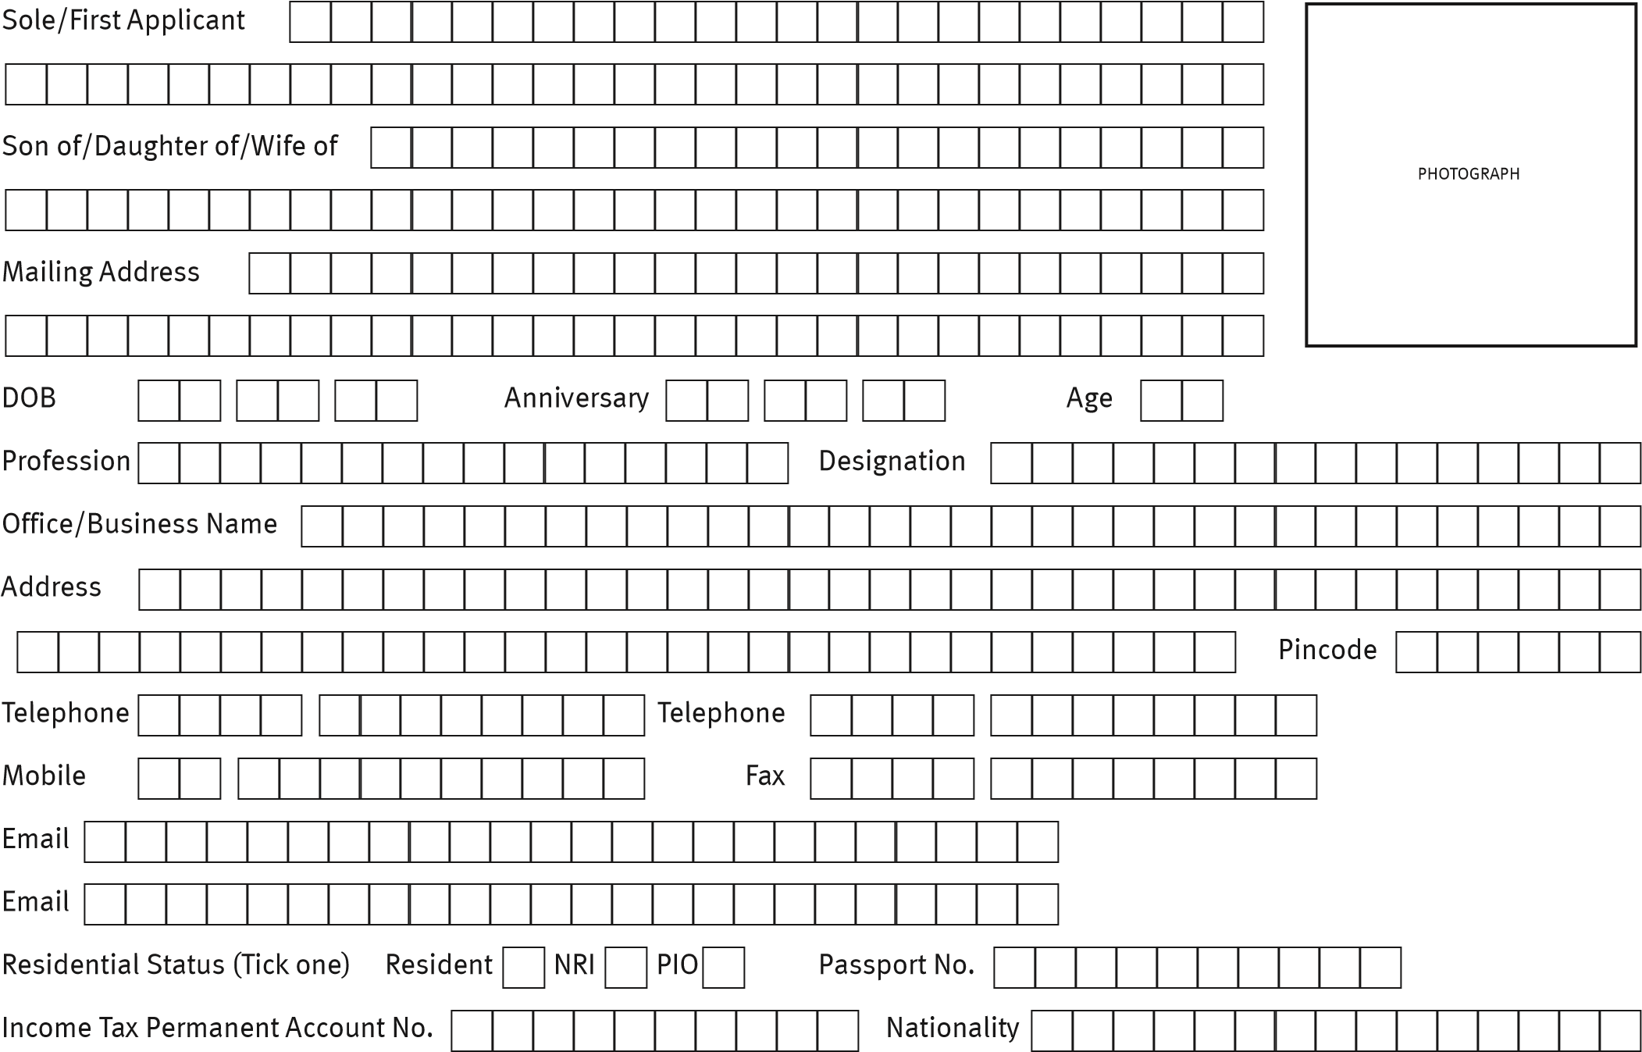
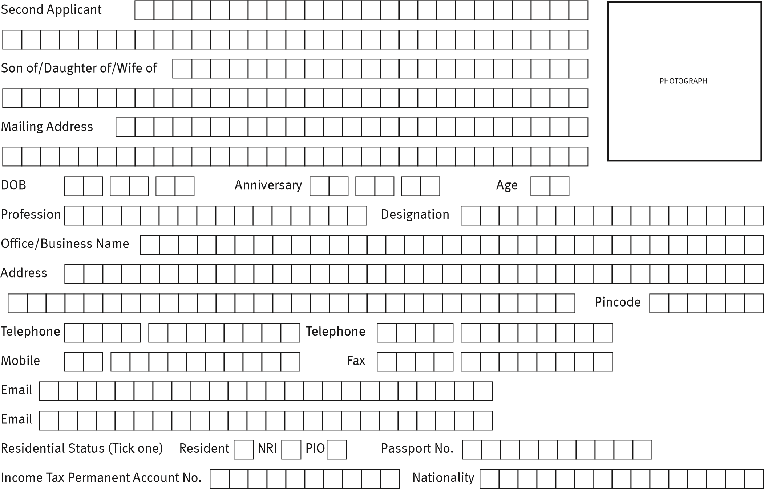

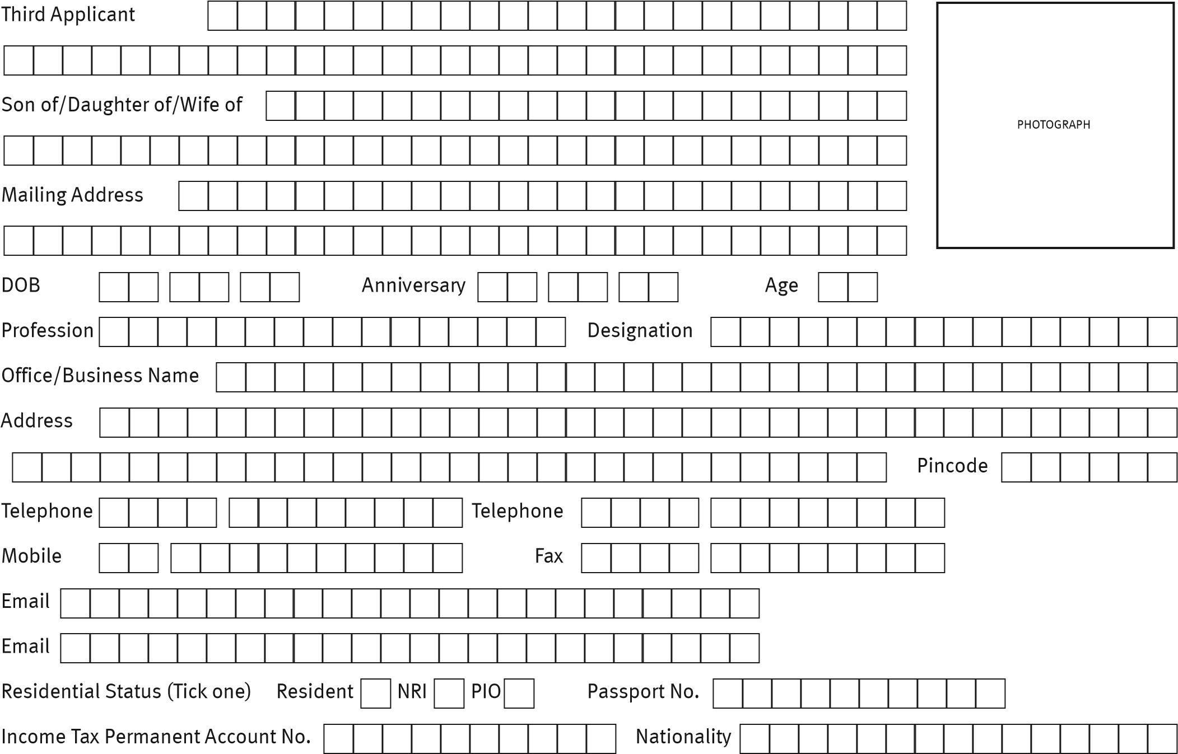

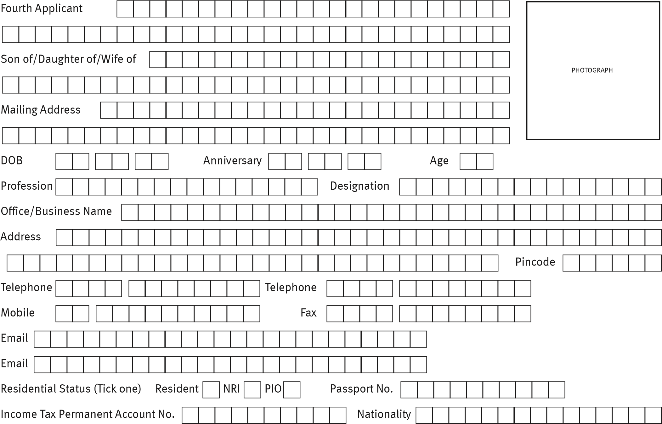

DETAIL OF PLOT REQUIRED FOR ALLOTMENT
Name of Project | WOODVIEW RESIDENCIES
Plot No. | No.________, Block __________,
Plot Size | ______________ sq. mts. (_______________sq. yards)
Sector | No._____________
Address of Property | Village _________, District Gurugram, Haryana

TOTAL PRICE
- Total Price of Plot: Rs. ___________________/- per Sq. Mtr. (Rs.______________/- per Sq. Yds.);

PAYMENT PLAN OPTED:
Down Payment Plan  🖵 | Development Linked/Installment Payment Plan  🖵
*(opt any one Payment Plan and tick the same)
Special Instructions/Remarks:_____________________________________________________
- Payments to be made by Demand Draft(s)/Pay Order(s)/Banker’s Cheque(s)/RTGS, NEFT, IMPS only, drawn in favour of “Orris Infrastructure Private Limited”, payable at Gurgaon.
- Allotment to Non Resident and National of Indian Origin shall be subject to Laws of Republic of India.
- For non-residents/foreign nationals of Indian origin all remittances, acquisition/transfer of the said Plot and compliance with the provisions of Foreign Exchange Management Act, 1999 (FEMA) or any other statutory enactments shall be the sole responsibility of the Applicant(s).

DECLARATION

I/We, the Applicant(s), do hereby declare that my/our application for allotment of the Plot to the Promoter is irrevocable and that the above particulars/information/details given by me/us are true and correct and nothing has been concealed therefrom. In case of any false or misleading information provided by the Applicant(s), and/or non-fulfillment of obligation of signing and registering the Buyers Agreement/Agreement for Sale within the stipulated timelines, the Promoter shall be entitled to cancel the provisional allotment and the Promoter shall be entitled to forfeit the Earnest Money deposited by the Applicant(s). I/We have read and understood the terms and conditions of the Application. Further, I unequivocally undertake to abide by the said terms and conditions.
Yours faithfully,
Date _____________________ Place _____________________
_____________________________________ __________________________________________
Signature of Sole/First Applicant Signature of Second Applicant (if any)
_____________________________________ __________________________________________
Signature of Third Applicant (if any) Signature of Fourth Applicant (if any)

FOR OFFICE USE ONLY
Provisional Registration of Plot Application: Accepted/Rejected
Name of Project | WOODVIEW RESIDENCIES
Plot No. | No._______ Block No. ___________
Plot Size | ___________ sq. mts. (_________sq. yards)
Sector No. | _____________
Address of Property | Village __________, District Gurugram, Haryana

TOTAL PRICE
- Total Plot Price: Rs. ___________________/- per Sq. Mtr. (Rs.______________/- per Sq. Yds.);

PAYMENT PLAN OPTED:
Down Payment Plan  🖵 | Development Linked/Installment Payment Plan  🖵
Direct contact with company Office / Project Site   🖵 | Real Estate Agent 🖵  having RERA registration # _____________

Payment received vide Cheque/DD/Pay Order/RTGS, NEFT, IMPS No.____________ dated _____________ for Rs. ____________________out of NRE/NRO/FC/SB/CUR/CA _______________________________ ACCT ________________________________________________

Special Instructions/Remarks______________________________________________________

Signature (Receiving Officer) Signature (Sales Head)

TERMS AND CONDITIONS
Terms & Conditions forming part of the Application for booking of a residential plot in upcoming project “WOODVIEW RESIDENCIES” situated at Sector 89 & 90, Villages Hayatpur & Badha, District Gurugram, Haryana.

- Definitions and Interpretation:
In this Application, the following words and expressions, when written in capital letters, shall have the meanings assigned herein. When not written in capital letters, such words and expressions shall be attributed to their ordinary meaning and/or as specified in the Buyer’s Agreement/Agreement for Sale.
“Agreement” shall mean the Buyer’s Agreement/Agreement for Sale which will be executed as per the standard format of the Developer.
“Plot” means the specific residential plot applied for by the Applicant(s), details of which have been set out in this Application.
“Applicant(s)” shall mean the applicant, applying for booking of the said Plot whose particulars are set out in this Application and who have appended their signatures on each page, as acknowledgement of having agreed to the terms and conditions of this Application and the Buyer’s Agreement/Agreement for Sale.
“Application” shall mean this application for booking of the Plot along with the terms and conditions and annexures contained herein.
“Buyer’s Agreement/Agreement for Sale” shall mean the Agreement for Sale which will be executed and registered between the Applicant(s), Promoter and the land owners.
“Delay Payment Charges” means interest at the rate equivalent to State Bank of India’s highest marginal cost of lending rate plus 2% (two percent) or such other rate prescribed under the applicable law.
“Earnest Money” shall mean 10% of the Total Price to be paid by the Applicant(s) as per the Payment Plan for due fulfillment of the terms and conditions of the Application/Buyer’s Agreement/Agreement for Sale.
“EDC” means the external development charges levied by the Government of Haryana, which shall be charged additionally as applicable and the same shall be paid by the Applicant(s) as and when demanded by the Developer.
“Force Majeure Event” shall include any event beyond the reasonable control of the Promoter which prevents, impairs or adversely affects the Developer’s ability to perform its obligation under the Application inter-alia including war or war-like situations, labour unrest or strikes, flood, drought, fire, cyclone, epidemics, pandemic, natural disaster, earthquake or any other natural calamities and delay on account of non-availability of steel and/or cement and/or other building materials, water supply or electric power or slow down strike or lock down or due to a dispute with the construction agency employed by the Promoter or due to any Court orders or, notice, order, rule, policy/ guidelines, decisions or notification of the Central or State Government and/or any other public or competent authority/tribunals/judicial/quasi-judicial bodies or due to any change in applicable law, applicable policy/guidelines or any delay on account of receipt of approvals, or for any other reason beyond the control of the Promoterand any other such event or circumstance similar or analogous to the foregoing.
“IDC” means the infrastructure development charges levied by the Government of Haryana, or any other charges which shall be charged additionally as applicable and the same shall be paid by the Applicant(s) as and when demanded by the Developer.
“Maintenance Agency” means the agency appointed/nominated by the Developer, to whom the Promoter may handover, the maintenance and upkeep of the Project/Residential Plotted Colony and who shall be responsible for providing the maintenance services within the Project/Residential Plotted Colony.
“Maintenance Charges” mean the charges payable periodically by the Applicant(s) for the maintenance and upkeep of the common areas and facilities in respect of the Project/Residential Plotted Colony more particularly detailed in Buyers Agreement/Agreement for Sale.

“Payment Plan” means the price list and schedule of payments as set out in Annexure-___ to this Application providing details of and price of the said Plot.
“Plot” means the specific Plot applied for by the Applicant(s), details of which have been set out in this Application.
“Project” shall mean part of the area of the Residential Plotted Colony, being developed under the name and style of “WOODVIEW RESIDENCIES” at Sector 89 & 90, Villages Hayatpur and Badha, District Gurugram, Haryana and registered under the Real Estate Act and the Haryana Real Estate (Regulation and Development) Rules, 2017 vide Registration No. RC/REP/HARERA/GGM/418/150/2020/34 dated 06.10.2020.
“Real Estate Act” shall mean Real Estate (Regulation and Development) Act 2016 read with Haryana Real Estate (Regulation and Development) Rules 2017 and or any amendment thereof.
“Residential Plotted Colony” means the colony being developed by the Promoter under the name and style of “WOODVIEW RESIDENCIES”, situated at Villages Hayatpur and Badha, District Gurugram, Haryana and where the said Plot and other components of the Project are located.
“Restricted Common Areas” means part of area in the Colony, meant for the exclusive use, enjoyment and access of certain Plot owner(s) in the entire Residential Plotted Colony to the exclusion of other plot owners, as opted for by the Applicant(s) more particularly detailed in Annexure ___.
“Total Price” shall mean the consideration for the Plot based on the area which shall comprise of the following:
- Total Plot Price: Rs. ___________________/- per Sq. Mtr. (Rs.______________/- per Sq. Yds.);

but does not include other amounts, charges, Interest Free Maintenance Security (IFMS), security amount, stamp duty etc. which are payable as and when demanded by the Promoter in accordance with the terms of this Application / Agreement for Sale.

“Taxes and Cesses” shall mean any and all taxes by way of Goods and Services Tax (GST), or any other taxes, cesses, charges, levies by whatever name called, payable at the rates prevailing at the time of respective payments, in connection with the development of the Project, now or in future including GST applicable on sale of the Plot.

II. Terms:
- The terms and conditions given wherein are only indicative to enable the Applicant(s) to acquaint himself/ herself with the terms and conditions as will be comprehensively set out in the Buyers Agreement/Agreement for Sale. For all intents and purposes and for the purpose of the Terms and Conditions set out in this Application, singular includes plural and masculine includes feminine and neuter gender.
- The Applicant(s) acknowledges that the Applicant(s) has visited and seen the Project site as well as the relevant documents/papers pertaining to the Scheduled Land/Project and is fully satisfied about the location of the project, right and interest of the Promoter to develop the Project/Residential Plotted Colony on the Scheduled Land and has understood all limitations and obligations in respect thereof. The Applicant(s) agrees that there will not be any further investigations or objections by him/her with respect to title/interest of the land owners (being subsidiaries of the Promoter and also individuals) and/or the right of the Promoter for the development of the Project on the Scheduled Land.
- The Applicant(s) confirms and represents that the Promoter has never indicated/promised/represented/given any impression of any kind in an explicit or implicit manner whatsoever, that the Applicant(s) shall have any right or title of any kind whatsoever, in any Land (other than the Plot), community facilities, EWS, shopping area etc. save and except, as mentioned herein.
- Upon the allotment of the Plot, the Applicant(s) shall pay the Total Price of the Plot in terms of the Payment Plan upon the demand being made by the Developer, from time to time, in this regard.
- The Promoter has made it clear to the Applicant(s) that it may carry out extensive developmental/construction activities now or in future in the Residential Plotted Colony in which the Project/Plot is located as the same is being developed in phases, and that the Applicant(s) has confirmed that the Applicant(s) shall not raise any objections or make any claims or default in any payments as demanded by the Promoter on account of inconvenience, if any, which may be suffered by the Applicant(s) due to such developmental / construction activities or incidental/related activities.
- It is made clear by the Promoter and understood by the Applicant(s) that the Applicant(s) shall have no rights including right of ownership in the Scheduled Land/Residential Plotted Colony, facilities and amenities, save and except, as specified herein. It is further clarified that the general common areas like parks, lawns, greens, roads, entrance, etc., facilities/amenities/community center, etc. of the Residential Plotted Colony are common and for the benefit of all allottees of the entire Residential Plotted Colony including the allottees of the Project. All rights and interest to develop the Scheduled Land shall vest solely with the Promoter and the Promoter hall have the sole and absolute authority to deal in any manner with such Scheduled Land, facilities and amenities. The Promoter relying on this specific undertaking of the Applicant(s) in this Application may finally agree to allot the Plot and this undertaking shall survive throughout the occupancy of the Plot by the Applicant(s), his/her legal representatives, successors, administrators, executors, assigns etc.
- The Plot applied for, along with the Project/Residential Plotted Colony, shall be subject to the Real Estate Act and Haryana Apartment Ownership Act, 1983 (if applicable) and/or Haryana Development and Regulation of Urban Area Act, 1975 (Acts), applicable in the State of Haryana, if any, or any statutory enactments or modifications thereof. In this regard, the Applicant(s) having full knowledge and understanding of all the laws, notifications and rules as are applicable to the State of Haryana and the area in general and the Project in particular, which have been duly explained by the Developer, agree to abide by the same.
- The Promoter may at its sole discretion develop other/recreational facilities for recreational purposes in the Project. The right of usage of such/recreational facilities, shall be limited to the Applicant(s) (and the occupants of the Plot claiming under them) and their dependants within the Project and is subject to the fulfilment of the terms and conditions as may be stipulated by the Developer. The Applicant(s) authorizes the Promoter to formulate, at the Developer’s sole discretion, appropriate management structure and policies, rules and regulations for the said community centre/recreational facilities and upon intimation of the formalities to be complied, the Applicant(s) undertakes to fulfil/comply with the same.
- The Total Price above includes Taxes and Cesses (consisting of Tax including but not limited to Goods and Services Tax paid or payable by the Promoter which may be levied, in connection with the Plot) as applicable on the date of this Application. In case there is any change/ modification in the applicable Taxes and Cesses, the subsequent amount payable by the Applicant(s) to the Promoter shall be increased/ reduced based on such change/modification. It is agreed that Goods and Services Tax is applicable on Delay Payment Charges. Pursuant to foregoing, Goods and Services Tax along with Delay Payment Charges applicable thereon will be computed as and when Applicant(s) will make such payments to the Promoterin terms of the Buyer’s Agreement/Agreement for Sale.
- The Total Price shall be escalation free, save and except increases which the Applicant(s) hereby agrees and undertakes to pay, on account of any revision in the External Development Charges, Infrastructure Development Charges, or any other statutory or other charges, Taxes and Cesses, fees, which may be levied or imposed by the concerned Authority(ies). The Promoter undertakes and agrees that while raising a demand on the Applicant(s) for increase in development charges, cost/charges imposed by the concerned Authorities, the Promoter shall enclose the said applicable law to that effect along with the demand letter being issued to the Applicant(s). Provided further that if there is any increase in the Taxes and Cesses after the expiry of the scheduled date of completion of the Project as per registration with the Haryana Real Estate Regulatory Authority under the Real Estate Act, the same shall not be charged from the Applicant(s).
- The Promoter shall periodically intimate in writing to the Applicant(s), the amount payable as stated in the Payment Plan and the Applicant(s) shall make payment demanded by the Promoter within the time and in the manner specified therein.
- The Applicant(s) agrees and understands that the Promoter shall have the right to adjust/appropriate the installment amount received from the Applicant(s) first towards the interest/Delayed Payment Charges and other sums, if any, due from the Applicant(s) and the balance, if any, towards the Total Price. Such adjustment/appropriation of payments shall be done at the sole discretion of the Promoter and the Applicant(s) undertakes not to object, protest or direct the Promoter to adjust the payments in any manner otherwise than as decided by the Developer.
- The Applicant(s) further understands and agrees that for the purposes of the Act, there is a variance in the value of the Plot inter-se each category as is required/permissible by the applicable laws. The Applicant(s) also understands that the common areas and facilities are common for the Residential Plotted Colony and same shall be used harmoniously by the Applicant(s) along with other occupants of the Residential plotted Colony without causing any hindrance or obstruction. As the interest of the Applicant(s) in the common areas is undivided and cannot be partitioned this would require the Applicant(s) to use the common areas within the Residential Plotted Colony only harmoniously along with other occupants in the Residential Plotted Colony without causing any inconvenience or hindrance to them.
- The Total Price includes price of Plot, and proportionate cost of construction of the common areas, External Development Charges, Infrastructure Development Charges, cost of providing electric connection to the Plot, water connection, sewer connection etc.
- The Applicant(s) understands that the Promoter shall treat 10% (Ten percent) of the Total Price to be paid/paid by the Applicant(s) as per the Payment Plan as Earnest Money to ensure due fulfillment, by the Applicant(s) of the Terms and Conditions as contained herein and as may be contained in the Buyer’s Agreement/Agreement for Sale. In the event of failure of the Applicant(s) to sign, return the Buyer’s Agreement/Agreement for Sale in its original form to the Promoter and registration of the Buyers Agreement/Agreement for Sale within 30 (thirty) days from the receipt of the Buyers Agreement/Agreement for Sale then the Promoter shall serve a notice to the Applicant(s) for rectifying the default, which if not rectified within 60(sixty) days from the date of the receipt of notice by the Applicant(s), the Promoter shall be entitled to cancel the booking and forfeit the entire Earnest Money along with the Delay Payment Charges, and thereafter refund the balance amount, if any, to the Applicant(s) within 90(ninety) days from such cancellation, without any interest. The Applicant(s) agrees that the conditions for forfeiture as stated hereinabove shall remain valid and effective till the execution and registration of the Conveyance Deed and that the Applicant(s) hereby authorizes the Promoter to affect such cancellation and forfeiture after providing a notice of 30 (thirty) days prior to such cancellation.
- The Applicant(s) is aware that the site plan, layout plan/zoning plans of the Project have been approved by the DTCP, Haryana and other authorities concerned. The Applicant(s) has seen and accepted the site plans, layout plan, zoning plan, RERA registration certificate(s), location of the Project/Plot, all of which have been duly prepared by the architects and consultants of the Promoter and approved by the competent authorities. The Promoter may carry out any additions and alterations in the sanctioned site plans, layout plans in respect of the Project/Residential Plotted Colony after following due process of law and as per the provisions of the Real Estate Act.
- If as a result of any legislation, order or rule or regulation made or issued by the Government, or any other authority or if the competent authority refuses, delays, withholds, or denies the grant of necessary approvals for the Project or the Plot comprised therein or if any matters relating to such approvals, permissions, notices, notifications by the competent authority(ies) becomes the subject matter of any lawsuit/writ before a competent court and the Promoter is unable to deliver the Plot even after the final allotment, the Applicant(s) confirms and acknowledges that the Promoter may refund all amounts received by it from the Applicant(s) without any interest or compensation whatsoever. The Applicant(s) undertakes not to raise any dispute or claim whatsoever in this regard.
- Possession and Conveyance Deed
  - Subject to Force Majeure conditions, the Promoter shall offer the possession of the Plot to the Applicant(s) on or before the date of validity of the RERA Registration certificate i.e. 15.07.2023. Subject to Force Majeure and fulfillment by the Applicant(s) of all the terms and conditions of this Application and the Buyers Agreement/Agreement for Sale including but not limited to timely payment by the Applicant(s) of the Total Price payable in accordance with Payment Plan, along with stamp duty, registration charges and other charges in connection thereto due and payable by the Applicant(s) and also subject to the Applicant(s) having complied with all formalities or documentation as prescribed by the Developer, the Promoter shall offer the possession of the Plot to the Applicant(s) as stipulated above.
  - Subject to sub-clause (a) above, in the event the Promoter fails to offer possession of the Plot to the Applicant(s) within the timelines stipulated in sub- clause (a), the Applicant(s) may either:
    - Opt to continue with the Project wherein the Applicant(s) shall be entitled for payment of delay compensation from the Developer, in which case the Applicant(s) agrees that it shall not have any other claims/rights, etc. of whatsoever nature, OR
    - the Applicant(s) may seek termination of the Buyer’s Agreement/Agreement for Sale by written intimation to the Developer. In such an event, the Promoter shall be liable to refund to the Applicant(s), the actual amounts paid by the Applicant(s) along with interest within the time stipulated under the Real Estate Act (excluding any interest paid/payable by the Applicant(s) on any delayed payment and paid up taxes), provided that the Applicant(s) executes and registers the all documents necessary for cancellation with Developer. No other claims whatsoever shall lie against the Promoter nor be raised otherwise or in any other manner by the Applicant(s).
In the event the Applicant(s) fails to or refuses to take possession of the Plot for no default on the part of the Developer, then the Applicant(s) shall not be eligible/entitled to delay compensation for the period from offer of handover of possession till actual physical possession by the Applicant(s). The Applicant(s) further confirms and undertakes that in such an event the Applicant(s) shall not withdraw from the Project and/or cancel the allotment and/or ask for refund of the amounts paid.
  - If, however, the offer of possession of the Plot is delayed due to Force Majeure, the time period for offering possession shall stand extended automatically to the extent of the delay caused under the Force Majeure circumstances. The Applicant(s) shall not be entitled to any compensation for the period of such delay. The Applicant(s) agrees and confirms that, in the event it becomes impossible for the Promoter to implement the Project due to Force Majeure conditions, then the Buyers Agreement/Agreement for Sale and the allotment of the Plot shall stand terminated and the Promoter shall refund (excluding any interest paid/payable by the Applicant(s) on any delayed payment and paid up Taxes and Cesses) to the Applicant(s) the entire amount received by the Promoter from the Applicant(s), without any interest on the same. After refund of the money paid by the Applicant(s), the Applicant(s) agrees that he/ she shall not have any rights, claims etc. against the Promoter and that the Promoter shall be released and discharged from all its obligations and liabilities under the Buyers Agreement/Agreement for Sale.
  - Upon receipt of the occupation certificate, the Promoter shall issue a written notice (“Intimation of Possession”) to the Applicant(s) requiring the Applicant(s) to complete the following requirements within the timelines prescribed under such Intimation of Possession and complete such other documentary requirements, as may be necessary, and the Promoter shall, after execution of all such documentation and receipt of all outstanding payments from the Applicant(s) including all dues payable under the Agreement or as may be payable because of any demands of any concerned authority, the Applicant(s) shall be entitled to take possession of the Plot after:
    - Payment of any unpaid amounts as provided herein and as otherwise applicable under applicable laws as mentioned in the notice of possession letter including submission of challans/receipts for deduction of TDS;
    - Execution of necessary indemnities, undertakings, maintenance agreement and the like as may be required or determined by the Promoter in respect of the Plot and in the formats prescribed by the Developer.
    - NOC (No Objection Certificate) or letter from Bank/Financial Institution to allow possession / registration of the property in the name of Applicant(s) / nominee, if applicable.
Failure of the Applicant(s) to pay the charges as stipulated in the Intimation of Notice and/or fails to complete the formalities of possession, the Applicant(s) shall continue to be liable to pay the maintenance charges of common areas and facilities of the Residential Plotted Colony.
  - Subject to the Applicant(s) fulfilling all its obligations stipulated herein and the Buyer’s Agreement/Agreement for Sale and taking the possession of the Plot in accordance with the Intimation of Possession, the Promoter shall prepare and execute a Conveyance Deed to transfer the title of the said Plot in favour of the Applicant(s). The Promoter shall notify the date(s) for execution and registration of the Conveyance Deed to the Applicant(s). The Applicant(s) agrees and undertakes to make itself available and present before the concerned Sub-Registrar for this purpose on the date(s) communicated to it for this purpose by the Developer.
  - However, if the Applicant(s) fails to execute the Conveyance Deed within the prescribed timelines, provided the Promoter has complied with all its obligations under the Buyers Agreement/Agreement for Sale and in accordance with law, the Applicant(s) confirms and undertakes that the Applicant(s) shall not raise any dispute or claim whatsoever. The Applicant(s) further undertakes to indemnify the Promoter(including its employees, directors, agents etc.) against all claims, actions, demands, litigation, penalty that may arise on account of default on the part of Applicant(s) for not executing the Conveyance Deed. In the event, the delay in execution of Conveyance deed or completion of formalities for taking possession of the Plot is on the part of the Applicant(s), then the Promoter shall not be liable for any consequences thereof.
  - The Applicant(s) agrees that if the Applicant(s) is in default of any of the payments as afore-stated, then the Promoter shall have the right to withhold registration of the Conveyance Deed in the Applicant’s favor till full and final settlement of all dues to the Promoter including the Delay Payment Charges is made by the Applicant(s). The Applicant(s) undertakes to execute the Conveyance Deed within the time stipulated by the Promoter in its written notice, failing which and subject to event of default provisions under the Buyer’s Agreement/Agreement for Sale the Applicant(s) authorizes the Promoter to cancel the allotment and terminate the Buyer’s Agreement/Agreement for Sale and to forfeit out of the amounts paid by him, the Earnest Money along with Delay Payment Charges, if any, and to refund the balance amount, if any, without any interest in the manner prescribed in the Agreement.
  - The Applicant(s) agrees and accepts that in case of any default/delay in payment as per the Payment Plan, the date of handing over of the possession shall be extended accordingly, till the payment of all outstanding amounts to the satisfaction of the Developer.
- The Plot allotted to the Applicant(s) can be used only for residential purposes and the Applicant(s) hereby undertakes to use and develop the Plot for residential purpose only and not for any other purpose whatsoever.
- The Applicant(s) further agrees and understands that the Applicant(s) shall be responsible for construction on the Plot allotted and for obtaining all the necessary permissions, sanctions and permits for the same on the Plot at the Applicant(s)’s sole costs and expenses. For this purpose, the Applicant(s) undertakes that to abide by all rules, bye-laws, notifications, circulars of the local authorities and shall conform, abide by and adhere to the same at all times.
- For the intents and purposes of developing the community in a time bound manner, the Applicant(s) shall commence construction of the house on the said Plot not later than 3 (three) years from the date of execution of conveyance deed/sale deed.
- The Applicant(s) undertakes and agrees that the development of the Plot and construction on the Plot shall be carried out strictly in accordance with the plans/nomenclature prepared by the Promoter in accordance with the Government Approved Zoning.
- The Applicant(s) agrees and undertakes not to divide the Plot into two or more Plots or into self-contained flats and further not to cause or permit to be done upon the Plot, anything, that may grow to be a nuisance or annoyance to the owners and occupiers of any adjoining or neighbouring plots/property and the Community as a whole.
- The Applicant(s) agrees and understands that the Applicant(s) shall abide by the community rules and regulations for the residents and visitors to the residential colony proposed to be developed by the Promoter which is more particularly known as “WOODVIEW RESIDENCIES” made by the Promoter from time to time, which the Promoter may, from time to time, amend in its sole and absolute discretion. The said rules and regulations (“the Community Rules and Regulations”) shall be made available by the Promoter at the time of possession of the Plot to the Applicant(s) and shall be binding on all the Applicant(s)/occupant(s) in the Project. The Promoter shall have a right to from time to time amend and update the Community Rules and Regulations. It shall be obligatory for all the applicant(s)/occupant(s) to abide by the Community Rules and Regulations which are incorporated as part and parcel of this Application.
- The Applicant(s) agrees to abide by the rules and regulations as prescribed by the Petroleum and Explosives Safety Organization (PESO) in terms of storage of hazardous, inflammable and Explosive substances within the Premises of the plot. The Provisions of the Inflammable Substances Act, 1952; The Petroleum Rules, 2002; The Gas Cylinder Rules, 2004 and /or any other relevant Act or Rule as applicable from time to time on the Project and Plots.
- The Applicant(s) undertakes that upon possession/execution of Conveyance Deed, he shall become the member of association/society of the Plot allottee(s) in the Residential Plotted Colony, as may be formed by the Promoter on behalf of the occupants in the Residential Plotted Colony. It is further agreed and understood by the Applicant(s) that he/she/it shall be charged for the maintenance for the part of the common areas and maintenance of the Residential Plotted Colony separately under a common invoice to be raised by the maintenance agency /association/society on monthly basis. In the event the aforesaid association is not formed within the timeframe prescribed under the Real Estate Act then till the formation of such association, the Maintenance Charges will be paid by the Applicant(s) from the handing over the possession of the Plot. The Applicant(s) shall pay the fees, subscription charges thereof and shall complete such documentation and formalities, as may be required by the Promoter for this purpose, as and when and if required such association is formed. In order to secure adequate provision of maintenance services, till such time, the association/society of the Plot allottee(s) is not formed, the Promoter shall appoint /nominate a Maintenance Agency to provide services as may be required to maintain upkeep, security etc. of the Residential Plotted Colony. Further, the Applicant(s) hereby undertakes to deposit with the Developer, as per the Payment Plan and to always keep deposited with the said association/society/ Maintenance Agency, as the case may be, Interest Free Maintenance Security (“IFMS”). The Applicant(s) undertakes to enter into a maintenance agreement with the said association/society/ Maintenance Agency.
- The Applicant(s) further agrees and undertakes to pay the Maintenance Charges as may be levied by the Maintenance Agency for the upkeep and maintenance of the Residential Plotted Colony and its common areas, utilities, equipment installed in the Colony and such other facilities forming part of the Residential Plotted Colony, within the timeliness provided in the Possession Notice. Further, the Applicant(s) agrees and undertakes to pay in advance, along with the last installment specified under Payment Plan, advance maintenance charges (AMC) equivalent to Maintenance Charges for a period of two years or as maybe decided by the Promoter/ Maintenance Agency at its discretion. Such charges payable by the Applicant(s) will be subject to escalation of such costs and expenses as may be levied by the Maintenance Agency.
- Time is of the essence with respect to the Applicant’s obligations to pay the Total Price as provided in the Payment Plan along with other payments such as applicable stamp duty, registration fee and other charges that will be more specifically stipulated in the Buyers Agreement/Agreement for Sale, to be paid on or before due date or as and when demanded by the Developer, as the case may be, and also to perform or observe all the other obligations of the Applicant(s) under the Agreement, failure of which shall attract Delayed Payment Charges. However, the Promoter may, in its sole discretion, waive its right to terminate the allotment/ Buyer’s Agreement/Agreement for Sale and enforce all the payments and seek specific performance of the Buyer’s Agreement/Agreement for Sale.
- The Applicant(s) hereby authorizes and permits the Promoter to raise finance/loan from any financial institution/bank by way of mortgage/charge/ securitization of the receivables, if any, accruing or likely to accrue therefrom, subject to the Plot being made free of any encumbrances at the time of execution of the conveyance/sale deed in favour of the Applicant(s) or his/her nominee. Such mortgage or charge shall not affect the right and interest of the Applicant(s).
- The Applicant(s) shall pay, from time to time, and at all times, the amounts which the Applicant(s) is liable to pay, as agreed, and to observe and perform all the covenants and conditions of the Application/Agreement and to keep the Promoter and its agents and representatives, indemnified and harmless against the said payments and observance and performance of the said covenants and conditions and also against any loss or damages that the Promoter may suffer as a result of non-payment, non-observance or non-performance of the said covenants and conditions by the Applicant(s). The Applicant(s) further undertakes to indemnify the Promoter and its agents and representatives and keep harmless and indemnified against any loss, damages, penalties, fines or any other charges levied on the Developer, its agents and representatives due to any misrepresentation on the part of the Applicant(s) due to any reason whatsoever.
- In case the Applicant(s) is a non-resident Indian or a foreign national of Indian origin then it shall be his responsibility to fully comply with all the provisions of Foreign Exchange Management Act, 1999 (“FEMA”), Reserve Bank of India Act, 1934 (“RBI Act”), any rules and/or guidelines made/issued there under and all other applicable laws including that of remittance of payment, acquisition/ sale /transfer of immovable properties in India. The Applicant(s) shall be solely responsible for any failure to comply with the applicable FEMA provisions, RBI Act and/or any rules or guidelines made there under. The Applicant(s) shall indemnify and keep and hold the Promoter and its Directors/employees/associates, etc. fully indemnified and harmless against any losses, damages, impositions or liabilities, including but not limited to any statutory liability, claim, action, penalties, charge, costs, expenses, etc. due to such failure. In the event of change of the residential status of the Applicant(s) subsequent to the execution of the Buyer’s Agreement/Agreement for Sale, they shall immediately intimate the same to the Promoter and comply with necessary formalities, if any, under the applicable laws.
- The Promoter shall not be responsible towards any third party making payment/remittances on behalf of the Applicant(s) and such third party shall not have right in the Application/allotment of the said Plot applied for herein in any manner whatsoever. The Promoter shall issue receipts for payment in favor of the Applicant(s) only.
- The Applicant(s) may with the permission from the Promoter raise and/ or avail loan from banks and other housing finance companies for purpose of raising finance towards the purchase of the Plot. Any delay on account of raising and/ or availing loan from banks and other housing finance companies shall not absolve the Applicant(s) from making timely payment of the Total Price or any part thereof and in which case Delayed Payment Charges shall be applicable.
- The Applicant(s) has specifically acknowledged with the Promoter that the allotment of the Plot shall be subject to the strict compliance of bye laws, rules etc. that may be framed by the Promoter for occupation and use of the Plot and such other conditions as per the applicable laws.
- The Applicant(s) shall not transfer, assign or create any further right with respect to his/her/their/it’s right, title, or interest, in allotment of the said Plot or any portion thereof until 10% of the Total Price along with all the dues or charges payable to the Promoter are paid. The Applicant(s) is, however entitled to get the name of his/her/their/its assignee(s) substituted in his/her/their/its place with the prior approval of the Promoter who may at its discretion permit the same on such terms and conditions and charges as it may deem fit. The Applicant(s) shall pay to the Promoter administrative charges as applicable from time to time in respect of such substitutions or nominations. Further the Applicant(s) shall be solely responsible and liable for all legal, monetary or any other consequences that may arise from such assignments and the Promoter shall have no direct or indirect involvement in any manner whatsoever. Any purported assignment by the Applicant(s) in violation of the Agreement shall be a default on the part of Applicant(s) entitling the Promoter to cancel the Buyer’s Agreement/Agreement for Sale and to avail of remedies as set forth in the Agreement.
- The Applicant(s) shall use and occupy the Plot for residential purposes in such manner and mode as may be provided in the Buyer’s Agreement/Agreement for Sale.
- In case of joint applicants, all communication shall be sent to the Applicant(s), whose name appears first and all the addresses given by him, which shall for the purposes be considered as served on all the applicants and no separate communication shall be necessary to the other named Applicant(s).
- The Applicant(s) shall inform the Promoter in writing of any change in the mailing address mentioned in failing which all demands, notices etc. by the Promoter shall be mailed to the address given in the Application and shall be deemed to have been received by the Applicant(s).
- The Terms and Conditions mentioned in the Buyers Agreement/Agreement for Sale shall be in addition to the terms and conditions mentioned herein. However, in case of any contradiction between the Terms and Conditions mentioned herein and terms and conditions specified in the Agreement for Sale, the terms and conditions specified in the Agreement for Sale, shall supersede the Terms and Conditions as set out herein.
- All or any disputes arising out or touching upon or in relation to the terms and conditions of this Application, including the interpretation and validity of the terms thereof and the respective rights and obligations of the Parties, shall be settled amicably by mutual discussion, failing which the same shall be settled through the adjudicating officer appointed under the Real Estate Act. All or any disputes arising out or in connection with this Agreement which are not within the scope and purview of Real Estate Act, shall be settled amicably by mutual discussion, failing which, the same shall be referred to and finally resolved by arbitration pursuant to the provisions of the (Indian) Arbitration and Conciliation Act, 1996 and amendments thereto. The seat and venue of the arbitration shall be Gurugram, India. The arbitral tribunal shall consist of a sole arbitrator to be appointed by the Developer.
I/We have fully read and understood the Terms and Conditions and agree to abide by the same. I/We understand that the Terms and Conditions given above are of indicative nature with a view to acquaint me/us with the terms and conditions as shall be comprehensively set out in the Agreement, which shall supersede the Terms and Conditions, to the extent of conflict or inconsistency, set out in this Application. I/We are fully aware that it is not incumbent upon the Promoter to send out notices/reminders in respect of my/our obligations set out in this Application and I/we shall be liable for any default committed by me/us in abiding by the Terms and Conditions. I/We have sought all clarifications that I/we required with respect to the terms, conditions and representations made by the Promoter and the Promoter has readily provided the same to me/us. I/We have now signed and paid all monies herein after being fully conscious of all my/our liabilities and obligations, including but not limited to the forfeiture of Earnest Money, Delayed Payment Charges, if any.
Date_________________________ Place_________________________
______________________________________ ____________________________
Signature of Sole/First Applicant Signature of Second Applicant (if any)

___________________________________ ______________________________ Signature of Third Applicant (if any) Signature of Fourth Applicant (if any)

ANNEXURE I
Part Site Plan of residential plotted colony “WOODVIEW RESIDENCIES” showing Project

ANNEXURE II
PAYMENT PLAN

1. In case of Down Payment Plan
S.no. | Installment | Percentage of total consideration | Amount (in Rs.) | Due Date | Interest | Balance Payable  (in Rs.)
 | On Booking | 10%
 | On BBA | 80%
 | On offer of Possession | 10%
 | Total Payable

OR

2. In case of Development linked installment plan

S. No | Stage of Payment | Percentage
1 | At the time of Booking along and allotment letter | 10%
2 | On completion of sewer line, STP, storm water drainage | 40%
3 | On completion of roads. | 30%
4 | On offer of Possession | 20%

